SAVEETHA INSTITUTE OF MEDICAL AND TECHNICAL SCIENCES
COMPUTER SCIENCE AND ENGINEERING PROGRAMME
UNIVERSITY PRACTICAL EXAMINATION, JAN 2023

LIST OF PROGRAMS
C Programs with Source Code and Output Screenshots (Questions 1 – 10)
Name | GUNAVATHI.A
Register Number | 192511374
Department / Section | B.E-COMPUTER SCIENCE AND ENGINEERING
Date | 06.10.2026

Question 1 Caesar cipher
Question
Write a C program for Caesar cipher involves replacing each letter of the alphabet with the letter standing k places further down the alphabet, for k in the range 1 through 25.
Program (q01.c)
#include <stdio.h>
#include <string.h>
#include <ctype.h>

char shift(char ch, int k) /* shift one character by k places */
{
if (isupper(ch)) return 'A' + ((ch - 'A' + k) % 26 + 26) % 26;
if (islower(ch)) return 'a' + ((ch - 'a' + k) % 26 + 26) % 26;
return ch; /* non letters are unchanged */
}

int main(void)
{
char text[200], enc[200], dec[200];
int k, i, t;

printf("Enter plaintext : ");
fgets(text, sizeof text, stdin);
text[strcspn(text, "\n")] = 0;
printf("Enter key k (1-25) : ");
scanf("%d", &k);
if (k < 1 || k > 25) { printf("Key must be between 1 and 25\n"); return 1; }

for (i = 0; text[i]; i++) enc[i] = shift(text[i], k);
enc[i] = 0;
for (i = 0; enc[i]; i++) dec[i] = shift(enc[i], -k);
dec[i] = 0;

printf("\nPlaintext : %s\n", text);
printf("Ciphertext : %s\n", enc);
printf("Decrypted : %s\n", dec);

printf("\nBrute force on the ciphertext (all 25 keys):\n");
for (t = 1; t <= 25; t++) {
printf("k=%2d : ", t);
for (i = 0; enc[i]; i++) putchar(shift(enc[i], -t));
putchar('\n');
}
return 0;
}
Output
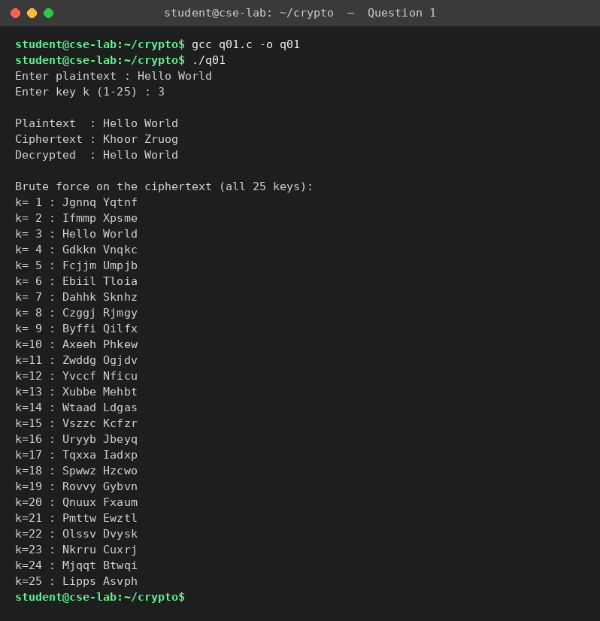

Question 2 Monoalphabetic substitution cipher
Question
Write a C program for monoalphabetic substitution cipher maps a plaintext alphabet to a ciphertext alphabet, so that each letter of the plaintext alphabet maps to a single unique letter of the ciphertext alphabet.
Program (q02.c)
#include <stdio.h>
#include <string.h>
#include <ctype.h>

int main(void)
{
char key[40], text[200], enc[200], dec[200], inv[26];
int i, used[26] = {0};

printf("Enter 26 letter cipher alphabet : ");
scanf("%s", key);
if (strlen(key) != 26) { printf("Key must contain 26 letters\n"); return 1; }
for (i = 0; i < 26; i++) {
key[i] = toupper(key[i]);
if (used[key[i] - 'A']++) { printf("Letter repeated - not a permutation\n"); return 1; }
inv[key[i] - 'A'] = 'A' + i; /* reverse mapping for decryption */
}
getchar();
printf("Enter plaintext : ");
fgets(text, sizeof text, stdin);
text[strcspn(text, "\n")] = 0;

for (i = 0; text[i]; i++) {
if (isalpha(text[i]))
enc[i] = key[toupper(text[i]) - 'A']; /* each letter -> unique letter */
else enc[i] = text[i];
}
enc[i] = 0;
for (i = 0; enc[i]; i++)
dec[i] = isalpha(enc[i]) ? inv[enc[i] - 'A'] : enc[i];
dec[i] = 0;

printf("\nplain : ABCDEFGHIJKLMNOPQRSTUVWXYZ\n");
printf("cipher : %s\n", key);
printf("\nCiphertext : %s\n", enc);
printf("Decrypted : %s\n", dec);
return 0;
}
Output (compiled with gcc and executed)
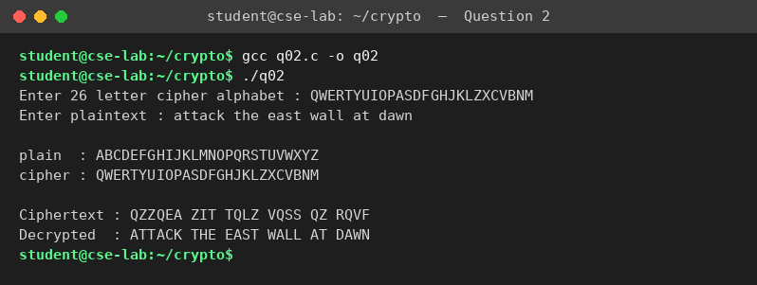

Question 3 Playfair cipher
Question
Write a C program for Playfair algorithm is based on the use of a 5 x 5 matrix of letters constructed using a keyword. Plaintext is encrypted two letters at a time using this matrix.
Program (q03.c)
#include <stdio.h>
#include <string.h>
#include <ctype.h>

char m[5][5];

void build(const char *key)
{
int used[26] = {0}, n = 0, i;
char all[60];
snprintf(all, sizeof all, "%sABCDEFGHIKLMNOPQRSTUVWXYZ", key);
for (i = 0; all[i]; i++) {
char c = toupper(all[i]);
if (c == 'J') c = 'I'; /* I and J share one cell */
if (isalpha(c) && !used[c - 'A']) { used[c - 'A'] = 1; m[n / 5][n % 5] = c; n++; }
}
}

void find(char c, int *r, int *col)
{
int i, j;
if (c == 'J') c = 'I';
for (i = 0; i < 5; i++) for (j = 0; j < 5; j++)
if (m[i][j] == c) { *r = i; *col = j; }
}

void digraph(char a, char b, char *x, char *y, int dir) /* dir=1 enc, -1 dec */
{
int r1, c1, r2, c2;
find(a, &r1, &c1); find(b, &r2, &c2);
if (r1 == r2) { *x = m[r1][(c1 + dir + 5) % 5]; *y = m[r2][(c2 + dir + 5) % 5]; }
else if (c1 == c2) { *x = m[(r1 + dir + 5) % 5][c1]; *y = m[(r2 + dir + 5) % 5][c2]; }
else { *x = m[r1][c2]; *y = m[r2][c1]; } /* rectangle rule */
}

int main(void)
{
char key[50], text[200], p[400], c[400], d[400];
int i, n = 0, len;

printf("Enter keyword : "); fgets(key, sizeof key, stdin);
key[strcspn(key, "\n")] = 0;
printf("Enter plaintext : "); fgets(text, sizeof text, stdin);
build(key);

printf("\n5 x 5 Playfair matrix:\n");
for (i = 0; i < 5; i++) printf(" %c %c %c %c %c\n", m[i][0], m[i][1], m[i][2], m[i][3], m[i][4]);

for (i = 0; text[i]; i++) /* keep letters only */
if (isalpha(text[i])) p[n++] = toupper(text[i]) == 'J' ? 'I' : toupper(text[i]);
p[n] = 0;
for (i = 0, len = 0; i < n; ) { /* build digraphs, insert X */
char a = p[i], b = (i + 1 < n) ? p[i + 1] : 'X';
if (a == b) { b = 'X'; i++; } else i += 2;
c[len++] = a; c[len++] = b;
}
c[len] = 0;
printf("\nDigraphs : ");
for (i = 0; i < len; i += 2) printf("%c%c ", c[i], c[i + 1]);
for (i = 0; i < len; i += 2) digraph(c[i], c[i + 1], &d[i], &d[i + 1], 1);
d[len] = 0;
printf("\nCiphertext : ");
for (i = 0; i < len; i += 2) printf("%c%c ", d[i], d[i + 1]);
for (i = 0; i < len; i += 2) digraph(d[i], d[i + 1], &c[i], &c[i + 1], -1);
printf("\nDecrypted : %s\n", c);
return 0;
}
Output (compiled with gcc and executed)
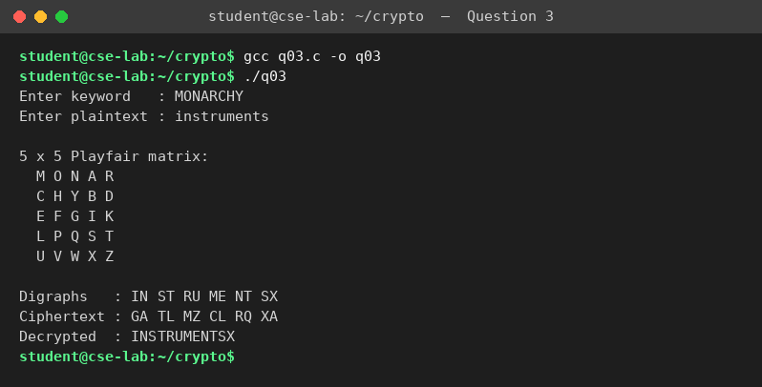

Question 4 Polyalphabetic (Vigenère) cipher
Question
Write a C program for polyalphabetic substitution cipher uses a separate monoalphabetic substitution cipher for each successive letter of plaintext, depending on a key.
Program (q04.c)
#include <stdio.h>
#include <string.h>
#include <ctype.h>

int main(void)
{
char text[200], key[50], enc[200], dec[200];
int i, j = 0, klen;

printf("Enter plaintext : "); fgets(text, sizeof text, stdin);
text[strcspn(text, "\n")] = 0;
printf("Enter key : "); scanf("%s", key);
klen = strlen(key);

printf("\nTableau row used for each key letter (shift = key letter - 'A'):\n");
for (i = 0; text[i]; i++) {
if (isalpha(text[i])) {
int k = toupper(key[j % klen]) - 'A'; /* separate shift per letter */
int base = isupper(text[i]) ? 'A' : 'a';
enc[i] = base + (text[i] - base + k) % 26;
printf("%c + %c(%2d) = %c\n", text[i], toupper(key[j % klen]), k, enc[i]);
j++;
} else enc[i] = text[i];
}
enc[i] = 0;

for (i = 0, j = 0; enc[i]; i++) {
if (isalpha(enc[i])) {
int k = toupper(key[j % klen]) - 'A';
int base = isupper(enc[i]) ? 'A' : 'a';
dec[i] = base + (enc[i] - base - k + 26) % 26;
j++;
} else dec[i] = enc[i];
}
dec[i] = 0;
printf("\nPlaintext : %s\nKey : %s\nCiphertext : %s\nDecrypted : %s\n",
text, key, enc, dec);
return 0;
}
Output (compiled with gcc and executed)
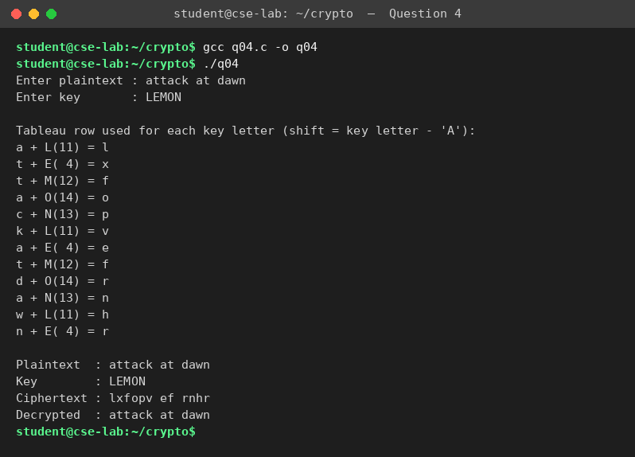

Question 5 Affine Caesar cipher
Question
Write a C program for generalization of the Caesar cipher, known as the affine Caesar cipher, has the following form: For each plaintext letter p, substitute the ciphertext letter C: C = E([a, b], p) = (ap + b) mod 26. A basic requirement of any encryption algorithm is that it be one-to-one. That is, if p ≠ q, then E(k, p) ≠ E(k, q). Otherwise, decryption is impossible, because more than one plaintext character maps into the same ciphertext character. The affine Caesar cipher is not one-to-one for all values of a. For example, for a = 2 and b = 3, then E([a, b], 0) = E([a, b], 13) = 3.
a. Are there any limitations on the value of b?
b. Determine which values of a are not allowed.
Program (q05.c)
#include <stdio.h>
#include <string.h>
#include <ctype.h>

int gcd(int a, int b) { return b ? gcd(b, a % b) : a; }

int inverse(int a) /* multiplicative inverse of a mod 26 */
{
int x;
for (x = 1; x < 26; x++) if ((a * x) % 26 == 1) return x;
return -1;
}

int main(void)
{
int a, b, p, ok, seen[26];
char text[200];

/* (b) which values of a are not allowed? test one-to-one property */
printf("Checking E([a,b],p) = (a*p + b) mod 26 for one-to-one mapping\n");
printf("Allowed a : ");
for (a = 1; a < 26; a++) if (gcd(a, 26) == 1) printf("%d ", a);
printf("\nNot allowed : ");
for (a = 1; a < 26; a++) if (gcd(a, 26) != 1) printf("%d ", a);
printf("\n(a must be coprime with 26, i.e. gcd(a,26) = 1)\n");

printf("\nExample a=2, b=3 : E(0) = %d, E(13) = %d -> not one-to-one\n",
(2 * 0 + 3) % 26, (2 * 13 + 3) % 26);

/* (a) any limitation on b? test every b with every valid a */
ok = 1;
for (a = 1; a < 26; a++) {
if (gcd(a, 26) != 1) continue;
for (b = 0; b < 26; b++) {
memset(seen, 0, sizeof seen);
for (p = 0; p < 26; p++) seen[(a * p + b) % 26]++;
for (p = 0; p < 26; p++) if (seen[p] != 1) ok = 0;
}
}
printf("\nAll 26 values of b (0..25) with every allowed a are one-to-one: %s\n",
ok ? "YES" : "NO");
printf("So b has no limitation. Total keys = 12 x 26 = 312\n");

/* encryption and decryption */
printf("\nEnter a : "); scanf("%d", &a);
printf("Enter b : "); scanf("%d", &b);
if (gcd(a, 26) != 1) { printf("a = %d is not allowed\n", a); return 1; }
getchar();
printf("Enter plaintext : "); fgets(text, sizeof text, stdin);
text[strcspn(text, "\n")] = 0;

printf("Ciphertext : ");
for (p = 0; text[p]; p++)
if (isalpha(text[p])) putchar('A' + (a * (toupper(text[p]) - 'A') + b) % 26);
else putchar(text[p]);
printf("\nDecrypted : ");
int ai = inverse(a), c;
for (p = 0; text[p]; p++)
if (isalpha(text[p])) {
c = (a * (toupper(text[p]) - 'A') + b) % 26;
putchar('A' + (ai * (c - b + 26)) % 26);
} else putchar(text[p]);
printf("\n");
return 0;
}
Output (compiled with gcc and executed)
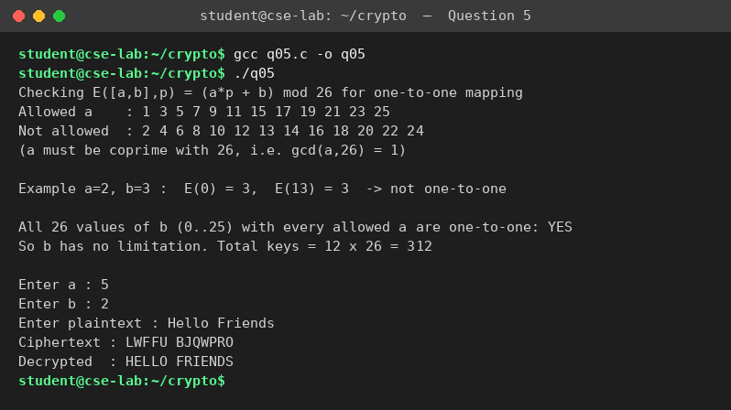
Result
(a) No limitation on b - any b from 0 to 25 gives a one-to-one mapping. (b) a is not allowed when gcd(a, 26) ≠ 1, i.e. a = 2, 4, 6, 8, 10, 12, 13, 14, 16, 18, 20, 22, 24 (and a = 0). Allowed: 1, 3, 5, 7, 9, 11, 15, 17, 19, 21, 23, 25.

Question 6 Breaking an affine cipher
Question
Write a C program for ciphertext has been generated with an affine cipher. The most frequent letter of the ciphertext is “B,” and the second most frequent letter of the ciphertext is “U.” Break this code.
Program (q06.c)
#include <stdio.h>
#include <string.h>
#include <ctype.h>

int main(void)
{
const char *top = "ETAOI"; /* most frequent English letters */
char c1, c2, ct[200];
int a, b, i, j, ai, x;

printf("Most frequent ciphertext letter : "); scanf(" %c", &c1);
printf("Second most frequent ciphertext letter : "); scanf(" %c", &c2);
c1 = toupper(c1) - 'A'; c2 = toupper(c2) - 'A';

printf("\nTrying plaintext guesses (most frequent, second) = ET, EA, TE ...\n\n");
printf("%-6s %-22s %s\n", "Guess", "Equations", "Key (a,b)");
for (i = 0; i < 5; i++)
for (j = 0; j < 5; j++) {
if (i == j) continue;
int p1 = top[i] - 'A', p2 = top[j] - 'A';
for (a = 1; a < 26; a++)
for (b = 0; b < 26; b++)
if ((a * p1 + b) % 26 == c1 && (a * p2 + b) % 26 == c2) {
int g = a, h = 26; /* gcd test for validity */
while (h) { int t = g % h; g = h; h = t; }
if (g == 1)
printf("%c%c %2d*%2d+b=%2d, %2d*%2d+b=%2d a=%2d, b=%2d\n",
top[i], top[j], a, p1, c1, a, p2, c2, a, b);
}
}

/* Assume E->B and T->U : solve 4a+b=1, 19a+b=20 (mod 26) */
for (a = 1; a < 26; a++)
for (b = 0; b < 26; b++)
if ((a * 4 + b) % 26 == c1 && (a * 19 + b) % 26 == c2) {
for (ai = 1; ai < 26; ai++) if ((a * ai) % 26 == 1) break;
printf("\nWith E->%c and T->%c : a = %d, b = %d, a^-1 = %d\n",
c1 + 'A', c2 + 'A', a, b, ai);
printf("Encryption : C = (%d p + %d) mod 26\n", a, b);
printf("Decryption : p = %d (C - %d) mod 26\n", ai, b);
printf("\nEnter a ciphertext to decrypt with this key : ");
scanf("%s", ct);
printf("Plaintext : ");
for (x = 0; ct[x]; x++)
putchar('a' + (ai * (toupper(ct[x]) - 'A' - b + 26)) % 26);
printf("\n");
return 0;
}
return 0;
}
Output (compiled with gcc and executed)
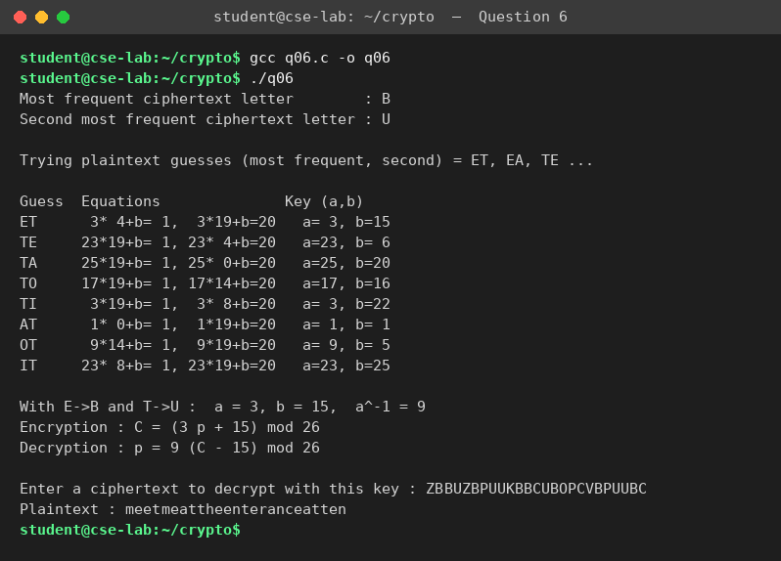
Result
Assuming E → B and T → U: 4a + b ≡ 1 and 19a + b ≡ 20 (mod 26), so a = 3 and b = 15. Encryption C = (3p + 15) mod 26, decryption p = 9(C − 15) mod 26.

Question 7 Decrypting a substitution cipher
Question
Write a C program for the following ciphertext was generated using a simple substitution algorithm.
53‡‡†305))6*;4826)4‡.)4‡);806*;48†8¶60))85;;]8*;:‡*8†83(88)5*†;46(;88*96*?;8)*‡(;485);5*†2:*‡(;4956*2(5*—4)8¶8*;4069285);)6†8)4‡‡;1(‡9;48081;8:8‡1;48†85;4)485†528806*81(‡9;48;(88;4(‡?34;48)4‡;161;:188;‡?;
Decrypt this message.
1. As you know, the most frequently occurring letter in English is e. Therefore, the first or second (or perhaps third?) most common character in the message is likely to stand for e. Also, e is often seen in pairs (e.g., meet, fleet, speed, seen, been, agree, etc.). Try to find a character in the ciphertext that decodes to e.
2. The most common word in English is “the.” Use this fact to guess the characters that stand for t and h.
3. Decipher the rest of the message by deducing additional words.
Program (q07.c)
#include <stdio.h>
#include <string.h>

/* cipher text split into symbols; symbols may be multi-byte UTF-8 characters */
const char *cipher =
"53‡‡†305))6*;4826)4‡.)4‡);806*;48†8¶60))85;;]8*;:‡*8†83"
"(88)5*†;46(;88*96*?;8)*‡(;485);5*†2:*‡(;4956*2(5*—4)8¶8*"
";4069285);)6†8)4‡‡;1(‡9;48081;8:8‡1;48†85;4)485†528806*81(‡9;48;(88;4(‡?34;48)4‡;161;:188;‡?;";

struct { const char *sym; char plain; } key[] = {
{"8",'e'},{";",'t'},{"4",'h'},{"‡",'o'},{")",'s'},{"*",'n'},{"5",'a'},{"6",'i'},
{"(",'r'},{"†",'d'},{"1",'f'},{"0",'l'},{"9",'m'},{"2",'b'},{"3",'g'},{"?",'u'},
{":",'y'},{"¶",'v'},{"]",'w'},{"—",'c'},{".",'p'}
};
#define NK (sizeof key / sizeof key[0])

int next(const char *s, char *sym) /* read one symbol, return its length */
{
unsigned char c = s[0];
int n = (c < 0x80) ? 1 : (c < 0xE0) ? 2 : 3;
memcpy(sym, s, n); sym[n] = 0;
return n;
}

int main(void)
{
char sym[8], syms[400][8];
int i, j, count = 0, freq[400] = {0}, uniq = 0;
char names[60][8];

for (i = 0; cipher[i]; ) {
i += next(cipher + i, sym);
strcpy(syms[count++], sym);
}
printf("Cipher text has %d characters\n\nStep 1 - frequency count:\n", count);
for (i = 0; i < count; i++) {
for (j = 0; j < uniq; j++) if (!strcmp(names[j], syms[i])) break;
if (j == uniq) strcpy(names[uniq++], syms[i]);
freq[j]++;
}
for (i = 0; i < 5; i++) { /* show the 5 commonest symbols */
int best = i;
for (j = i + 1; j < uniq; j++) if (freq[j] > freq[best]) best = j;
char t[8]; int f = freq[i];
strcpy(t, names[i]); strcpy(names[i], names[best]); strcpy(names[best], t);
freq[i] = freq[best]; freq[best] = f;
printf(" %s occurs %2d times\n", names[i], freq[i]);
}
printf(" -> '8' is most frequent, so 8 = e\n");

int the = 0;
for (i = 0; i + 2 < count; i++)
if (!strcmp(syms[i], ";") && !strcmp(syms[i+1], "4") && !strcmp(syms[i+2], "8")) the++;
printf("\nStep 2 - the trigram ;48 occurs %d times -> ;48 = 'the' (; = t, 4 = h, 8 = e)\n", the);

printf("\nStep 3 - deduce the other letters from words, giving the key:\n ");
for (i = 0; i < (int)NK; i++) printf("%s=%c ", key[i].sym, key[i].plain);

printf("\n\nDecrypted message:\n");
for (i = 0; i < count; i++) {
for (j = 0; j < (int)NK; j++)
if (!strcmp(key[j].sym, syms[i])) { putchar(key[j].plain); break; }
if (j == (int)NK) putchar('?');
}
printf("\n");
return 0;
}
Output (compiled with gcc and executed)
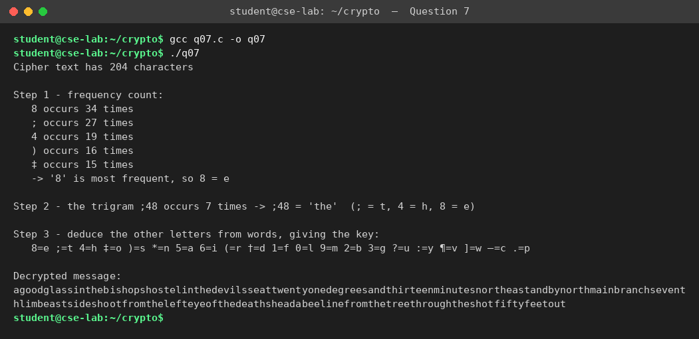
Result
Plaintext: “A good glass in the bishop's hostel in the devil's seat — twenty-one degrees and thirteen minutes — northeast and by north — main branch seventh limb east side — shoot from the left eye of the death's-head — a bee line from the tree through the shot fifty feet out.”

Question 8 Keyword monoalphabetic cipher
Question
Write a C program for monoalphabetic cipher is that both sender and receiver must commit the permuted cipher sequence to memory. A common technique for avoiding this is to use a keyword from which the cipher sequence can be generated. For example, using the keyword CIPHER, write out the keyword followed by unused letters in normal order and match this against the plaintext letters:
plain: a b c d e f g h i j k l m n o p q r s t u v w x y z
cipher: C I P H E R A B D F G J K L M N O Q S T U V W X Y Z
Program (q08.c)
#include <stdio.h>
#include <string.h>
#include <ctype.h>

int main(void)
{
char keyword[30], cipher[27], plain[200], enc[200], dec[200];
int used[26] = {0}, n = 0, i;

printf("Enter keyword : "); scanf("%s", keyword);
getchar();
printf("Enter plaintext : "); fgets(plain, sizeof plain, stdin);
plain[strcspn(plain, "\n")] = 0;

for (i = 0; keyword[i]; i++) { /* keyword letters first */
int c = toupper(keyword[i]) - 'A';
if (!used[c]) { used[c] = 1; cipher[n++] = 'A' + c; }
}
for (i = 0; i < 26; i++) /* then unused letters in order */
if (!used[i]) cipher[n++] = 'A' + i;
cipher[n] = 0;

printf("\nplain : a b c d e f g h i j k l m n o p q r s t u v w x y z\ncipher : ");
for (i = 0; i < 26; i++) printf("%c ", cipher[i]);

for (i = 0; plain[i]; i++)
enc[i] = isalpha(plain[i]) ? cipher[toupper(plain[i]) - 'A'] : plain[i];
enc[i] = 0;
for (i = 0; enc[i]; i++)
if (isalpha(enc[i])) dec[i] = 'a' + (strchr(cipher, enc[i]) - cipher);
else dec[i] = enc[i];
dec[i] = 0;
printf("\n\nPlaintext : %s\nCiphertext : %s\nDecrypted : %s\n", plain, enc, dec);
return 0;
}
Output (compiled with gcc and executed)
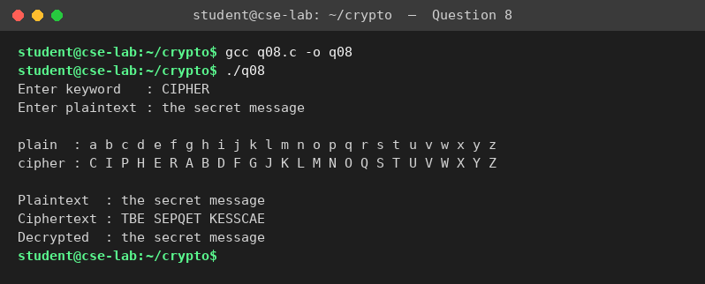

Question 9 PT-109 Playfair message
Question
Write a C program for PT-109 American patrol boat, under the command of Lieutenant John F. Kennedy, was sunk by a Japanese destroyer, a message was received at an Australian wireless station in Playfair code:
KXJEY UREBE ZWEHE WRYTU HEYFS
KREHE GOYFI WTTTU OLKSY CAJPO
BOTEI ZONTX BYBNT GONEY CUZWR
GDSON SXBOU YWRHE BAAHY USEDQ
Program (q09.c)
#include <stdio.h>
#include <string.h>
#include <ctype.h>

char m[5][5];

void build(const char *key)
{
int used[26] = {0}, n = 0, i;
char all[100];
snprintf(all, sizeof all, "%sABCDEFGHIKLMNOPQRSTUVWXYZ", key);
for (i = 0; all[i]; i++) {
char c = toupper(all[i]);
if (c == 'J') c = 'I';
if (isalpha(c) && !used[c - 'A']) { used[c - 'A'] = 1; m[n / 5][n % 5] = c; n++; }
}
}

void pos(char c, int *r, int *k)
{
int i, j;
if (c == 'J') c = 'I';
for (i = 0; i < 5; i++) for (j = 0; j < 5; j++) if (m[i][j] == c) { *r = i; *k = j; }
}

int main(void)
{
char key[60], ct[300] = "", line[100], pt[300];
int i, n = 0, r1, c1, r2, c2;

printf("Enter Playfair keyword : "); fgets(key, sizeof key, stdin);
key[strcspn(key, "\n")] = 0;
printf("Enter ciphertext (4 lines, 5 letter groups):\n");
for (i = 0; i < 4; i++) { fgets(line, sizeof line, stdin); strcat(ct, line); }
build(key);

printf("\nMatrix built from keyword:\n");
for (i = 0; i < 5; i++) printf(" %c %c %c %c %c\n", m[i][0], m[i][1], m[i][2], m[i][3], m[i][4]);

for (i = 0; ct[i]; i++) if (isalpha(ct[i])) ct[n++] = toupper(ct[i]);
ct[n] = 0;
for (i = 0; i < n; i += 2) { /* decrypt each digraph */
pos(ct[i], &r1, &c1); pos(ct[i + 1], &r2, &c2);
if (r1 == r2) { pt[i] = m[r1][(c1 + 4) % 5]; pt[i + 1] = m[r2][(c2 + 4) % 5]; }
else if (c1 == c2) { pt[i] = m[(r1 + 4) % 5][c1]; pt[i + 1] = m[(r2 + 4) % 5][c2]; }
else { pt[i] = m[r1][c2]; pt[i + 1] = m[r2][c1]; }
}
pt[n] = 0;
printf("\nCiphertext : %s\n", ct);
printf("Plaintext : %s\n", pt);
return 0;
}
Output (compiled with gcc and executed)
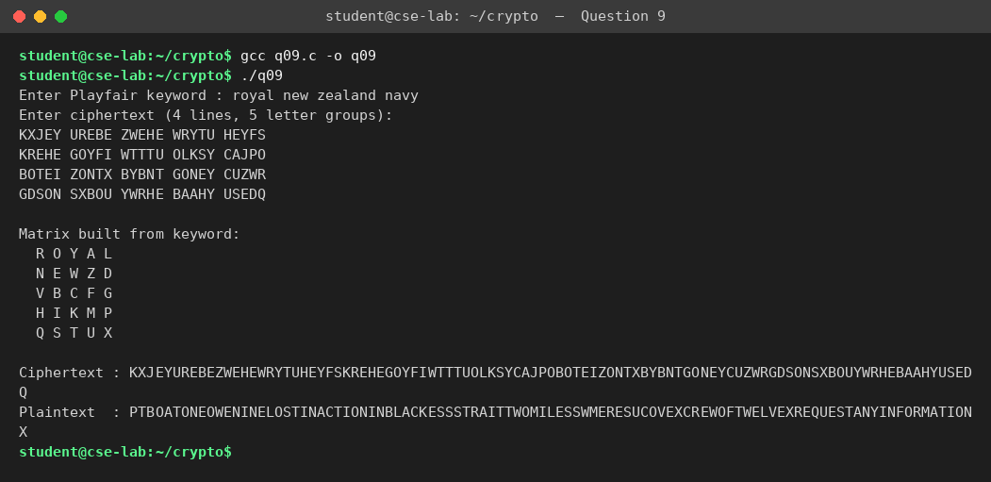
Result
The key is “royal new zealand navy”. Plaintext: PT BOAT ONE OWE NINE LOST IN ACTION IN BLACKETT STRAIT TWO MILES SW MERESU COVE X CREW OF TWELVE X REQUEST ANY INFORMATION X

Question 10 Playfair encryption with given matrix
Question
Write a C program for Playfair matrix:
M F H I/J K
U N O P Q
Z V W X Y
E L A R G
D S T B C
Encrypt this message: Must see you over Cadogan West. Coming at once.
Program (q10.c)
#include <stdio.h>
#include <string.h>
#include <ctype.h>

char m[5][5];

void pos(char c, int *r, int *k)
{
int i, j;
if (c == 'J') c = 'I';
for (i = 0; i < 5; i++) for (j = 0; j < 5; j++) if (m[i][j] == c) { *r = i; *k = j; }
}

int main(void)
{
const char *matrix = "MFHIKUNOPQZVWXYELARGDSTBC"; /* given matrix, row by row */
char text[200], p[300], out[300];
int i, n = 0, len = 0, r1, c1, r2, c2;

for (i = 0; i < 25; i++) m[i / 5][i % 5] = matrix[i];
printf("Playfair matrix:\n");
for (i = 0; i < 5; i++) printf(" %c %c %c %c %c\n", m[i][0], m[i][1], m[i][2], m[i][3], m[i][4]);

printf("\nEnter message : "); fgets(text, sizeof text, stdin);
for (i = 0; text[i]; i++) if (isalpha(text[i])) p[n++] = toupper(text[i]);
p[n] = 0;

printf("Prepared text : ");
for (i = 0; i < n; ) { /* split into digraphs */
char a = p[i], b = (i + 1 < n) ? p[i + 1] : 'X';
if (a == b) { b = 'X'; i++; } else i += 2;
pos(a, &r1, &c1); pos(b, &r2, &c2);
printf("%c%c ", a, b);
if (r1 == r2) { out[len++] = m[r1][(c1 + 1) % 5]; out[len++] = m[r2][(c2 + 1) % 5]; }
else if (c1 == c2) { out[len++] = m[(r1 + 1) % 5][c1]; out[len++] = m[(r2 + 1) % 5][c2]; }
else { out[len++] = m[r1][c2]; out[len++] = m[r2][c1]; }
}
out[len] = 0;
printf("\nCiphertext : ");
for (i = 0; i < len; i += 2) printf("%c%c ", out[i], out[i + 1]);
printf("\n");
return 0;
}
Output (compiled with gcc and executed)
